COMPUTER VISION AND RADIOLOGY FOR COVID-19 DETECTION

¹K.Sushmithawathi ² Prof.P.Indra
*1PG Scholar-Communication Systems , Department Of Electronics And Communication Engineering, Government College Of Engineering,Salem-11,Tamilnadu,India.
*2Assistant Professor, Department Of Electronics And Communication Engineering ,Government College Of Engineering,Salem-11,Tamilnadu,India.

Corresponding Author:  Sushmithawathi k  Email: sushmik13@gmail.com | Abstract— COVID-19 is spreading rapidly throughout the world .Over 128,000 people have died and millions of cases have been reported in 210 countries .Respiratory systems get affected by this virus. So, by using X ray and CT scan various methods were done to detect corona virus. Here in this paper each step like preprocessing ,segmentation, classification are discussed from the existing system along with the advantages and disadvantages and the future steps are also made. Some of the methods like CNN,ANN,and semantic classification are discussed along with the noise removal from the images and k-means, fuzzy clustering segmentation are also discussed. By image processing the radiology images of covid affected patients are processed into different steps for filtering and classifying the images to detect the virus. An existing system also involving AI methods to detect corona virus are also discussed and classification is also made. This system helps to identify people affected by pneumonia or corona at an early stage.  Keywords: ANN,CNN,Covid-19, Fuzzy clustering ,K-means, Pneumonia, Preprocessing, Segmentation.
  Article Information
  Received | : | Month 01 2021
  Revised | : | Month 01 2021
  Accepted | : | Month 01 2021
  Published | : | Month 01 2021
Copyright © 2021: Author name and Author name .This is an open access distribution, and reproduction in any medium, provided Access article distributed under the Creative Commons Attribution License the original work is properly cited License, which permits unrestricted use.
Citation: Author name and Author name .“Title of the paper”, Journal of Science, Computing and Engineering Research, 1(2), 75-87, 2021.

I. INTRODUCTION (HEADING 1)
Corona virus was first reported in Wuhan,China .It is a contagious disease and start to spread all over the world .Over 5,371,169 people died due to this virus.And Doctors advise to maintain social distance and wear face mask to avoid contact with the people.RT-PCR test is normally used to diagnosis covid-19 but by using radiology image based covid-19 detection would consume time.Various methods in radiology images which includes CT scan and X ray images are normally used .And ultrasound images are also used to detect covid-19 .
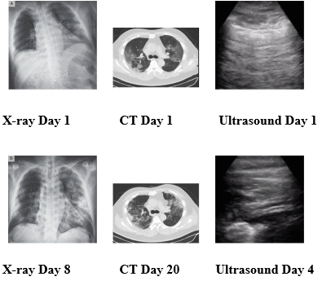
Figure 1 Covid-19 progression in different image modes

- IMAGE ENHANCEMENT

"Ultrasound image enhancement” by S. H. Contreras Ortiz, T. Chiu and M. D. Fox, here in this paper Ultrasound with machine learning technique is used which provides the fast and more accurate respiratory failure.
Disadvantage:
Compared to X-ray Ultrasound images tend to be noisy due to low penetration of sound waves. The quality of the image has to be improved by deconvolution method.

"COVID-19 image data collection: Prospective predictions are the future”, by J. P. Cohen, P. Morrison, L. Dao, K. Roth, T. Q. Duong and M. Ghassemi in this paper using X-ray images covid detection is made and it is accurate when compared to the ultrasound images.
Disadvantages:
Accuracy level has to be improved and any abnormalities of early stage of covid-19 is not seen in X-ray
images
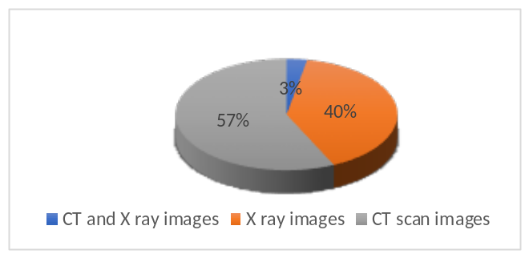

Figure 2: Usage of Radiology images
Here the network process of detecting covid is given which includes preprocessing, sample classification and post classification steps.
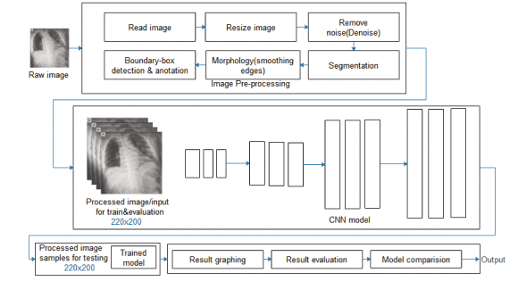
Figure 3:Frame network showing input preprocessing, sample classification
and post classification process

CT scan images are also used to detect covid which has high accuracy when compared to Xray and ultrasound images

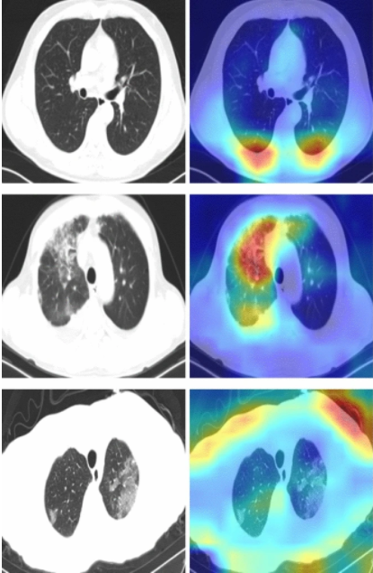

Figure 4:Covid detection in CT scan image

B. PREPROCESSING
Various noise from the image has to be removed like gaussian noise, salt and pepper noise, poison noise etc.. “Investigation on the effect of a Gaussian blur in image filtering and segmentation” by E. Gedraite and M. Hadad.Preprocessing has to be done for noise removal and better result.

C. SEGMENTATION
To get meaningful result, object in the image are detected and features are extracted ,this process comes under segmentation. Various segmentation like region based, cluster based and edge detection method is also done. By calculating the threshold value the pixel value can be determined ,which is given in "Prediction models for diagnosis and prognosis of covid-19 infection: Systematic review and critical appraisal"byL. Wynants et al
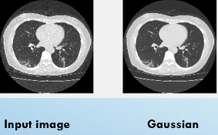

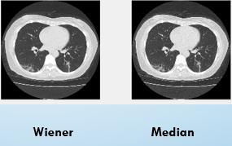
Figure 5:Different filters used in CT scan image
D. NEURAL NETWORK CLASSIFICATION
Different types of classification are used to detect covid-19 virus.CNN,ANN,KNN are some of the classifiers used and deep neural network method is also used. Deep convolutional neural network in which automatically diagnoses covid-19 affected patients.
LSTM and other algorithms are also used in detecting the novel corona virus .Using CNN in deep learning method used for effective diagnosis of covid-19.

CNN architecture which manages to perform complex tasks .And which includes resnet,mobilenet,alexnet etc.. Google net which receives error rate of 6.67%,Alexnet receives error rate of 17%.Resnet error rate is under 3.6%.Accuracy level of Reasnet is much better in detecting covid-19.

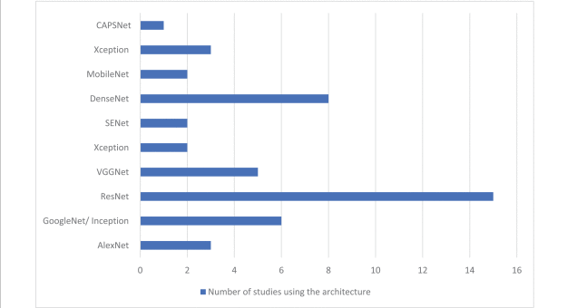

Figure 6:CNN Architecture

M. F. Aslan, M. F. Unlersen, K. Sabanci and A. Durdu proposed CNN using bayesnet ,it combines multiple pre trained CNN to detect the virus and the accuracy is 97%

Al-antari et al presented a diagnostic tool on YOLO predictor to detect the virus and the accuracy is greater than 90%

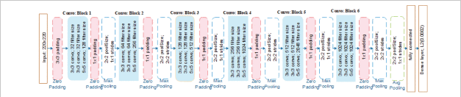

Figure 7: Feature detection and classification

This CNN benefits deep learning technique and also demonstrating the overfitting issue

t-SNE embedding method which is also used in layer adjusting the output of the network.and both the testing and the training data is given. It helps to map the input data to the desired label.

E. ARTIFICIAL INTELLIGENCE FOR DETECTION

In CNN 121 layers are created known as Chexnet to detect covid virus and also different types of pneumonia.

ANN method is used in segmentation and the robust features are also detected. Deep residual network in which maps between the input and the output layer of the image and detect the virus.

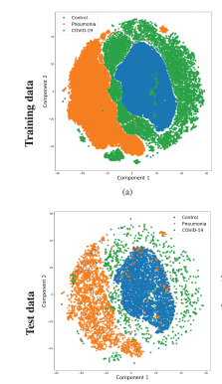

Deep neural network is performed and the input and output layer is mapped
xl=Hl(xl−1)+xl−1

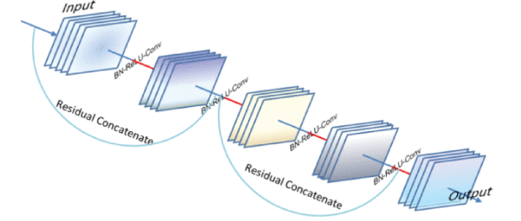
Figure 8: Deep neural network architecture

CONCLUSION AND DIRECTION FOR FUTURE RESEARCH
Here, various existing systems are given and the virus detection is made by various methods of input images like Xray, CT scan images and Ultrasound images. And in the preprocessing and segmentation various techniques are involved. Also CNN,ANN and using artificial intelligence method covid-19 detection is made. To obtain best accuracy level in each step various comparison of techniques has to be involved i.e. by comparing more than five filters in preprocessing for better noise removal also in segmentation comparison has to be done.In the final classification the better neural network with multiple number of layers has to be done. And hence the better detection of covid-19 virus can be easily detected with the high accuracy level.
REFERENCES
[1] I. D. Apostolopoulos and T. A. Mpesiana, "COVID-19: Automatic detection from X-Ray images utilizing transfer learning with convolutional neural networks", Phys. Eng. Sci. Med., vol. 43, no. 2, pp. 635-640, Jun. 2020.
[2] A. Krizhevsky and I. G. E. S. Hinton, "ImageNet classification with deep convolutional neural networks", Proc. Adv. Neural Inf. Process. Syst. (NIPS), pp. 1097-1105, 2012.
[3]E. El-Din Hemdan, M. A. Shouman and M. E. Karar, "COVIDX-net: A framework of deep learning classifiers to diagnose COVID-19 in X-ray images", arXiv:2003.11055, 2020, [online] Available:
[4] L. Wynants et al., "Prediction models for diagnosis and prognosis of covid-19 infection: Systematic review and critical appraisal", BMJ, vol. 369, pp. 1-16, 2020.
[5] E. Dong, H. Du and L. Gardner, "An interactive web-based dashboard to track COVID-19 in real time", Lancet Infectious Diseases, vol. 20, no. 5, pp. 533-534, 2020.
[6] O. Taiwo and A. E. Ezugwu, "Smart healthcare support for remote patient monitoring during COVID-19 quarantine", Informat. Med. Unlocked, vol. 20, Jan. 2020.
[7] D. Singh, V. Kumar, Vaishali and M. Kaur, "Classification of COVID-19 patients from chest CT images using multi-objective differential evolution–based convolutional neural networks", Eur. J. Clin. Microbiol. Infectious Diseases, vol. 39, no. 7, pp. 1379-1389, Jul. 2020.
[8]A. Jaiswal, N. Gianchandani, D. Singh, V. Kumar and M. Kaur, "Classification of the COVID-19 infected patients using DenseNet201 based deep transfer learning", J. Biomol. Struct. Dyn., vol. 24, no. 2, pp. 381-409, 2020.
[9] M. Barstugan, U. Ozkaya and S. Ozturk, "Coronavirus (COVID-19) classification using CT images by machine learning methods", arXiv:2003.09424, 2020, [online] Available: http://arxiv.org/abs/2003.09424.
[10]A. Narin, C. Kaya and Z. Pamuk, "Automatic detection of coronavirus disease (COVID-19) using X-Ray images and deep convolutional neural networks", arXiv:2003.10849, 2020, [online] Available: http://arxiv.org/abs/2003.10849.
[11]A. Abbas, M. M. Abdelsamea and M. M. Gaber, "Classification of COVID-19 in chest X-Ray images using DeTraC deep convolutional neural network", arXiv:2003.13815, 2020, [online] Available: http://arxiv.org/abs/2003.13815.
[12] S. Hu, Y. Gao, Z. Niu, Y. Jiang, L. Li, X. Xiao, et al., "Weakly supervised deep learning for COVID-19 infection detection and classification from CT images", arXiv:2004.06689, 2020, [online] Available: https://arxiv.org/abs/2004.06689.
[13] M. A. Al-Antari, C.-H. Hua, J. Bang and S. Lee, "‘Fast deep learning computer-aided diagnosis of COVID-19 based on digital chest X-Ray images", Int. J. Speech Technol., vol. 51, no. 5, pp. 2890-2907, May 2021.
[141 I. A. Hashem et al., "A machine learning solution ramework for combatting COVID-19 in smart cities from multiple dimensions", medRxiv, 2020.
[15] S. Lalmuanawma, J. Hussain and L. Chhakchhuak, "Applications of machine learning and artificial intelligence for COVID-19 (SARS-CoV-2) pandemic: A review", Chaos Solitons Fractals, vol. 139, Oct. 2020.
[16] O. N. Oyelade and A. E. Ezugwu, "A case-based reasoning framework for early detection and diagnosis of novel coronavirus", Informat. Med. Unlocked, vol. 20, Jan. 2020.
[17]T. Ozturk, M. Talo, E. A. Yildirim, U. B. Baloglu, O. Yildirim and U. R. Acharya, "Automated detection of COVID-19 cases using deep neural networks with X-Ray images", Comput. Biol. Med., vol. 121, Jun. 2020.
[18]L. Wang and A. Wong, "COVID-Net: A tailored deep convolutional neural network design for detection of COVID-19 cases from chest radiography images", arXiv:2003.09871, 2020, [online] Available
[19] D. Kauret and Y. Kaur, "Various image segmentation techniques: A review", Int. J. Comput. Sci. Mobile Comput., vol. 3, no. 5, pp. 809-814, 2014.
[20] J. Kukačka, V. Golkov and D. Cremers, "Regularization for deep learning: A taxonomy", arXiv:1710.10686, 2017, [online] Available: http://arxiv.org/abs/1710.10686.
[21] I. Nusrat and S.-B. Jang, "A comparison of regularization techniques in deep neural networks", Symmetry, vol. 10, no. 11, pp. 648, Nov. 2018.
[22] A. Krizhevsky and I. G. E. S. Hinton, "ImageNet classification with deep convolutional neural networks", Proc. Adv. Neural Inf. Process. Syst. (NIPS), pp. 1097-1105, 2012.
[23]K. Simonyan and A. Zisserman, "Very deep convolutional networks for large-scale image recognition", arXiv:1409.1556, 2014, [online] Available: https://arxiv.org/abs/1409.1556.
[24] F. Chollet, "Xception: Deep learning with depthwise separable convolutions", arXiv:1610.02357, 2016, [online]
[25] .H. Ko, H. Chung, W. S. Kang, K. W. Kim, Y. Shin, S. J. Kang, et al., "COVID-19 pneumonia diagnosis using a simple 2D deep learning framework with a single chest CT image: Model development and validation", J. Med. Internet Res., vol. 22, no. 6, Jun. 2020.
[26]S. H. Yoo, H. Geng, T. L. Chiu, S. K. Yu, D. C. Cho, J. Heo, et al., "Deep learning-based decision-tree classifier for COVID-19 diagnosis from chest X-Ray imaging", Frontiers Med., vol. 7, pp. 427, Jul. 2020
[27]H. Panwar, P. K. Gupta, M. K. Siddiqui, R. Morales-Menendez and V. Singh, "Application of deep learning for fast detection of COVID-19 in X-Rays using nCOVnet", Chaos Solitons Fractals, vol. 138, Sep. 2020.
[28]Coronavirus Death Toll, [online] Available: https://www.worldometers.info/coronavirus/coronavirus-death-toll/.
[29]L. A. Rousan, E. Elobeid, M. Karrar and Y. Khader, "Chest X-Ray findings and temporal lung changes in patients with COVID-19 pneumonia", BMC Pulmonary Med., vol. 20, no. 1, pp. 1-9, Dec. 2020.
[30] J. Cleverley, J. Piper and M. M. Jones, "The role of chest radiography in confirming COVID-19 pneumonia", BMJ, vol. 370, pp. m2426, Jul. 2020.
[31]O. I. Obaid, M. A. Mohammed and S. Mostafa, "Long short-term memory approach for coronavirus disease prediction", J. Inf. Technol. Manage., vol. 12, no. 1, pp. 11-21, 2020.
[32].S. Albahli, A. Algsham, S. Aeraj, M. Alsaeed, M. Alrashed, H. T. Rauf, et al., "COVID-19 public sentiment insights: A text mining approach to the gulf countries", Comput. Mater. Continua, vol. 67, no. 2, pp. 1613-1627, 2021.
[33]A. S. Al-Waisy, S. Al-Fahdawi, M. A. Mohammed, K. H. Abdulkareem, S. A. Mostafa, M. S. Maashi, et al., "COVID-CheXNet: Hybrid deep learning framework for identifying COVID-19 virus in chest X-Rays images", Soft Comput., Nov. 2020.
[34]A. S. Al-Waisy, M. A. Mohammed, S. Al-Fahdawi, M. S. Maashi, B. Garcia-Zapirain, K. H. Abdulkareem, et al., "COVID-DeepNet: Hybrid multimodal deep learning system for improving COVID-19 pneumonia detection in chest X-Ray images", Comput. Mater. Continua, vol. 67, no. 2, pp. 2409-2429, 2021.
[35] K. H. Abdulkareem, M. A. Mohammed, A. Salim, M. Arif, O. Geman, D. Gupta, et al., "Realizing an effective COVID-19 diagnosis system based on machine learning and IOT in smart hospital environment", IEEE Internet Things J., Jan. 2021.
[36]M. A. Mohammed, K. H. Abdulkareem, A. S. Al-Waisy, S. A. Mostafa, S. Al-Fahdawi, A. M. Dinar, et al., "Benchmarking methodology for selection of optimal COVID-19 diagnostic model based on entropy and TOPSIS methods", IEEE Access, vol. 8, pp. 99115-99131, 2020.
[37]M. Abed Mohammed, K. Hameed Abdulkareem, B. Garcia-Zapirain, S. A. Mostafa, M. S. Maashi, A. S. Al-Waisy, et al., "A comprehensive investigation of machine learning feature extraction and classification methods for automated diagnosis of COVID-19 based on X-Ray images", Comput. Mater. Continua, vol. 66, no. 3, pp. 3289-3310, 2021.

